**User Manual**

**508: Loop Detected ec500 error.core**

**Introduction:**

The ec500 is an expandable analog video synth system based on the ideas laid out by Jonas Bers in his CHA/V project. Briefly, the core concept is this: The VGA standard is readily hackable because it breaks out the six necessary components – red, green, blue, hsync, vsync, and ground – into separate pins. It’s also fairly forgiving of signals out of spec (although the ec500 tries to keep those to a minimum).

The CHA/V project takes advantage of this, and of the availability of cheapo ($5!) VGA tester boards. Jonas’s original concept involved soldering wires directly to the back of the tester board; subsequently he & various other contributors have developed various refinements & offshoots. The ec500 is our 508: Loop Detected offshoot/refinement/expansion of this concept. You can learn more at Jonas’s website: <https://jonasbers.com/chav/>

The error.core is the hub of the ec500 system – it takes 12V DC power, regulates it down to 5VDC, and provides an expansion bus that delivers power and hsync/vsync to expansion modules. It also has the connector where various interfaces – currently just VGA, others TBD – attach.

It has 9 oscillators, all of them square-wave. 6 are simple, not voltage-controllable, and provided by a single 40106 IC. 2 of them are provided by a 556 timer IC, and are voltage controllable with variable pulse-width. 1 is provided by the VCO in a 4046 PLL chip, which also provides a phase-comparison circuit. All of the oscillators are syncable, and 8 have switchable capacitors for speed control.

Beyond that, there are three mix busses (R, G, B), as well as switches to control whether RGB signals are passed thru from whatever external source is connected.

**Getting Started**

First, you’ll need to connect the components. There are three rectangular IDC box headers on the error.core, and each one is a different size, to help make it clear what goes where. When connecting the ribbon cables, be sure you’re using the correct cable for the various connectors – they should just fit into the plastic surround, with no extra pins visible.

The cable ends and the boxes have a ridge and a slot that will match up when you have things right-way-round. Don’t force them! Look for the ridge & make sure it’s lined up with the slot.

Here’s what the whole system, including the i/o expander, looks like when hooked up:

If you bought the complete system, you should have received everything you see in the photo above:

* The ec500 error.core
* The i/o expander
* A short 14-pin cable to connect those two components
* The VGA adapter
* A slightly longer 16-pin cable to connect the error.core to the VGA adapter
* A little red VGA tester, probably with Chinese lettering on it

You should also have received the following items, not pictured above:

* A 12VDC power supply
* A 3-way power splitter pigtail
* A bunch of little colored jumper wires with bare metal tips

It is absolutely possible to use the system without the i/o expander. If you want/need to do that, then you’ll need to install three jumpers (which should have been included as well), like so, into the right-hand expansion header on the error.core:

Once you have the components connected as shown in the picture above, you’ll want to connect a VGA monitor to the left VGA connector on the VGA adapter.

The ec500 system runs on 12V DC, and requires a power supply with a center-positive tip. Most supplies you have lying around will be of this type, but if you’re using a supply that we didn’t send you, look for this symbol:

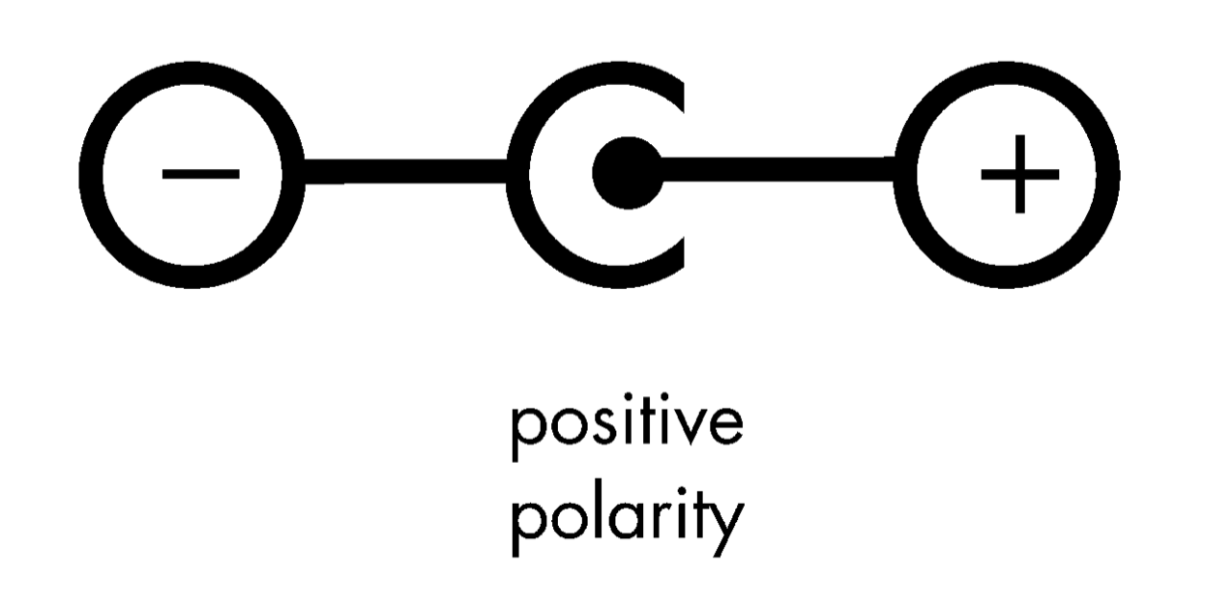

The little red VGA tester needs to be powered separately. If you got the full kit from us, you should have received a little power splitter pigtail for precisely this purpose. Go ahead and plug it all in, and if everything looks right, power it on! There is typically a red LED on the red VGA tester, and there is a yellow LED on the error.core, so you should be able to tell if power is flowing.

Now that you’re hooked up and powered on, let’s take a tour of the ec500 error.core.

**What is what**

L

N

M

K

J

H

F

G

C

D

E

B

A



**A: vertical and horizontal sync**

See the appendix for an explanation of the role sync plays in a video system. For this intro, you just need to know that patching from these sync headers to the sync inputs on the individual oscillators will (usually) stabilize the lines/bars/whatever you’re sending from that oscillator to the screen. Each sync header has 8 holes, so you can patch sync to every oscillator.

**B: expansion header B**

Where you’ll plug in additional expansion modules, potentially including another i/o expander, as well as other future modules TBD. This header has 12VDC, 5VDC, ground, hsync and vsync on it.

**C: sync input**

Every oscillator has one of these. See “A” above for an explanation.

**D: rate control**

Controls the rate at which the oscillator oscillates. If this were an audio synthesizer, this would control the pitch of the tone you hear. In a video oscillator, this typically controls the number and width of lines/bars on the screen. Play around with this control, turning it in fine increments, and you’ll find settings where the bars suddenly go diagonal, or start to curve and waver. This control is your main expressive control on the error.core.

**E: cv in**

The three oscillators on the left -- #1, #4, and #7 – can be voltage controlled, meaning their rate of oscillation can be modified by a voltage patched in to this input. There are multiple voltage sources on the i/o expander. On the error.core, any oscillator output can be a CV source, so just play around & see what happens.

**F: phase comparators**

Oscillator #1 is based on a 4046 phase-locked loop chip, which also includes two phase comparators. Input two signals into the two jacks on the “in” block, and the phase comparators will output something (some voltage) on the two jacks on the “out” block. Honestly, the top one doesn’t do much, but the bottom output will produce some neat effects – patch 2 oscillators into the “in” block and then patch the bottom output into one of the RGB mix buses. Note: On the error.core, these two in/out blocks are the only blocks where the individual holes do different things. Everywhere else on the error.core, the multiple holes in the blocks have the same signal present on all.

**G: out**

Every oscillator on the error.core has an output block. Patch from here into one (or more) of the RGB mix blocks, into the CV (or sync) input of another oscillator, and/or into the phase comparator inputs.

**H: vga adapter interface**

This is where the VGA adapter board + cable connect. In the future there may be other adapters available, such as for other modular video synthesis systems.

**J: power connector**

This is where you plug in the 12VDC power!

**K: rgb passthru switches**

With these switched left (off), whatever signal your VGA source is outputting [mostly] goes nowhere. (you may see some ghosting/artifacts even with these switches off, in keeping with the cheap hacky nature of this whole system.) With these switched right (on), whatever signal your VGA source is outputting will be fed into the RGB mix that the error.core is outputting (just before the knob in the mix signal chain). This feature is perhaps most useful if you use a composite-to-VGA adapter as your VGA source, instead of the red VGA tester, and plug in something (a VCR, a camera, whatever).

**L: expansion header A**

Where you’ll plug in the i/o expander. In addition to 12VDC, 5VDC, ground, hsync, and vsync, this expansion bus also has sends and returns for the R, G, & B mixes. This is what enables the i/o expander’s “RGB Rotate” function.

**M: main mix controls**

There are three identical mix busses, since VGA has separate red, green & blue signals. These knobs control the master level of each mix bus & are the last thing in the output chain before the signal leaves the error.core.

**N: main mix headers**

These are the headers where you patch various signals to be mixed together. In the interest of space, you don’t get individual relative level control of each signal you patch in here, although there are three all-purpose attenuators on the i/o expander that can be used for that purpose.

-- Ross Grady, July 16, 2019